4. Develop a system using UML for implementing Stock Maintenance System. In this system, the customer can place orders and purchase items with the aid of the stock dealer and central stock system. These orders are verified and the items are delivered to the customer. Then the stock details are to be updated accordingly.

Class diagram: -

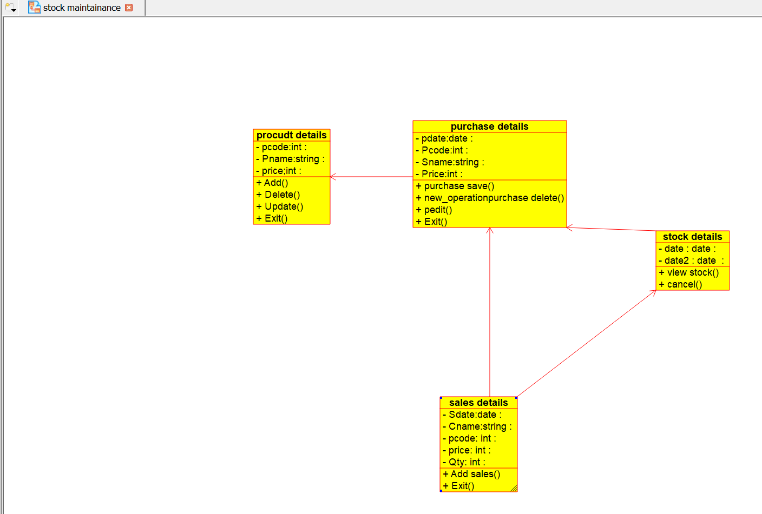

Use case diagram:-

